Zero Trust Network Access (ZTNA) with
Zscaler: Securing User-to-Application
Connectivity.

List of Teammates:-

S.NO | NAME | COLLEGE NAME | MAIL ID
1. | Rithanya S A | Adharsh Vidhyalaya College  of Arts and Science for  Women | rithanyasakthivel45@gmail.com
2. | Mohanapriya M | Adharsh Vidhyalaya College  of Arts and Science for  Women | mohanajeeva63@gmail.com
3. | Kalaiarasi R | Adharsh Vidhyalaya College  of Arts and Science for  Women | rajenthiran19604gmail.com

Project details
Title: Zero Trust Network Access (ZTNA) with Zscaler: Securing User-to-Application Connectivity
• AI-Enhanced User Protection (AIUP)
AI-Enhanced User Protection (AIUP) is a next-generation security framework that leverages artificial intelligence and machine learning to verify user identities and protect online platforms from cyber threats. Unlike traditional security measures that rely on static credentials like passwords or even two-factor authentication (2FA), AIUP continuously analyzes user behavior to create a dynamic, evolving "trust score" for each individual. AIUP is essential for modern online security because it addresses the limitations of perimeter-based defenses. As cyber threats become more sophisticated—with attackers using stolen credentials, phishing, and social engineering—relying solely on "what you know" (passwords) or "what you have" (tokens) is no longer sufficient. AIUP adds a third, continuous layer: "who you are" based on how you behave. This system helps organizations prevent account takeovers, reduce fraud, and ensure that the person interacting with a platform is genuinely who they claim to be, throughout their entire session.

Abstract:
The limitations of legacy VPN architectures in addressing modern security threats, particularly lateral movement and over-privileged network access, necessitate a paradigm shift towards Zero Trust principles. This project details the comprehensive design, deployment, and management of a Zero Trust Network Access (ZTNA) solution leveraging Zscaler Private Access (ZPA) within a large scale institutional network. The project aims to replace broad network-level access with application-specific, identity-driven connectivity. By deploying Zscaler App Connectors within the data center and integrating the platform with existing Identity Providers (Azure AD) and endpoint security tools, the architecture ensures that all user-to-application connections are established through a cloud-native broker. This approach renders internal applications "invisible" to the internet, eliminating the attack surface. Furthermore, the project explores the integration of Zscaler with security ecosystems, including SIEM platforms (like QRadar) for centralized logging and MISP for consuming threat intelligence to enable adaptive access policies. The result is a robust, scalable security framework that enforces least-privilege access, provides comprehensive audit trails, and significantly enhances the institution's resilience

Use Case Scenarios:
Scenario 1: Secure Remote Access for Faculty to ERP System
A faculty member working from home needs to access the university's ERP system to upload student grades. Using Zscaler Private Access (ZPA), they connect securely without being placed on the internal network. The system verifies their identity via Azure AD MFA and checks their device posture before granting access.
Output:
• User identity verified (Faculty_Group)
• Device posture compliant (AV active, OS up-to-date)
• Secure micro-tunnel established to ERP Application only
• Network remains completely invisible to the user
Scenario 2: External Researcher Accessing a Specific Database
An external research collaborator from another institution requires temporary access to a single research database hosted on VIT's servers. The administrator creates a time-limited, application-specific policy in Zscaler. The researcher accesses only the authorized database without any visibility into the rest of the VIT network.
Output:
• External user identity verified via temporary credentials
• Access policy enforced (Time-limited: 7 days, Application: Research-DB only)
• Database server remains hidden from internet scanners
• Session automatically terminates after policy expiry
Scenario 3: Student Access to Online Examination Portal
During final exams, thousands of students simultaneously access the internal online examination portal from various locations. Zscaler ZPA ensures that only authenticated students with compliant devices can reach the exam server. The system prevents DDoS attacks on the login page and blocks any attempts to access other internal resources.
Output:
• Mass user authentication handled via cloud scalability
• Each student connected only to the exam application

• Lateral movement to grade database or other servers blocked
• Exam server IP address remains concealed from the internet
Scenario 4: IT Administrator Performing Server Maintenance
An IT administrator needs to perform critical updates on an internal application server. Instead of connecting via VPN and gaining full network access, they use ZPA to connect directly to the specific server's management interface. The session is monitored in real-time, and any anomalous behavior (e.g., accessing unauthorized servers) is automatically terminated.
Output:
• Admin identity verified with MFA
• Direct micro-tunnel to Server-Management-Interface only
• All admin keystrokes and commands logged for audit
• Attempt to access another server automatically blocked
Scenario 5: Mergers and Acquisitions – Temporary Contractor Access
A contractor hired during a university system upgrade needs temporary access to a specific file server to migrate data. Using Zscaler ZPA, the contractor is granted application-specific access without being added to the university's Active Directory or given VPN credentials. The access is revoked automatically after the project timeline
. Output:
• Contractor identity verified via separate IdP integration
• Access granted to File-Server-Migration share only
• All file transfer activities logged in Zscaler and SIEM
• Access automatically revoked after 30-day project end date

Stage-1
Title Of the Project: -

Zero Trust Network Access (ZTNA) with Zscaler: Securing User-to-Application Connectivity.
Overview: -
The project aims to develop an AI-driven identity verification system that enhances online security by analysing and verifying user identities based on their online behaviour patterns. This system uses advanced machine learning techniques to create a robust user profile, distinguishing between legitimate users and suspicious activities. It addresses the pressing issue of unauthorised access, fraudulent transactions, and cyber threats across various online platforms and services.
The primary objective is to enhance online security significantly by scrutinising and validating user identities through their online behaviour. The system employs advanced machine learning techniques such as deep learning, neural networks, and natural language processing to establish comprehensive behavioural profiles for each user, which adapt and evolve with the user's behaviour over time. Real-time anomaly detection is a key feature of the system, identifying deviations from established user behaviour profiles and responding promptly to mitigate potential security threats.
Multi-factor verification is also implemented to bolster security, triggering additional verification steps when anomalies are detected. User and administrator alerts ensure transparent communication and provide guidance on resolving potential security issues. Secure data storage and management components are included to protect sensitive user profiles and anomaly data.
The system includes an integration layer for seamless interaction with various online platforms and services. Monitoring and reporting are integrated for performance and security, providing transparency and accountability. Scalability and load balancing are designed to handle growing user bases, while security and compliance are prioritised by encrypting data in transit and at rest, employing firewalls, intrusion detection systems, and adhering to data protection and privacy regulations.
Cloud infrastructure is an optional option for flexibility and scalability. Continuous training and optimization of machine learning models ensure the system remains effective against evolving threats and user behaviours. Geographic distribution can enhance redundancy and performance by deploying components in multiple geographic regions

Multi-factor verification is also implemented to bolster security, triggering additional verification steps when anomalies are detected. User and administrator alerts ensure transparent communication and provide guidance on resolving potential security issues. Secure data storage and management components are included to protect sensitive user profiles and anomaly data.
The system includes an integration layer for seamless interaction with various online platforms and services. Monitoring and reporting are integrated for performance and security, providing transparency and accountability. Scalability and load balancing are designed to handle growing user bases, while security and compliance are prioritised by encrypting data in transit and at rest, employing firewalls, intrusion detection systems, and adhering to data protection and privacy regulations.
Cloud infrastructure is an optional option for flexibility and scalability. Continuous training and optimization of machine learning models ensure the system remains effective against evolving threats and user behaviours. Geographic distribution can enhance redundancy and performance by deploying components in multiple geographic

List of Vulnerability Table:
Practice Website:
S.no | Vulnerability Name | CWE – No
1 | Broken Access Control | CWE-65  Windows Hard link
2 | Security Misconfiguration | CWE-489  Active Debug Code
3 | Software Supply Chain Failures | CWE-447  Use of Obsolete
4 | Cryptographic Failures | CWE-331  Insufficient Entropy
5 | Injection | CWE-114  Process Control

6 | Insecure design | CWE-269  Improper privilege management
7 | Authentication failures | CWE-259  Use of hard coded password
8 | Software or data integrity failure | CWE-426  Untrusted search path
9 | Security logging and Alerting failures | CWE-221  Information loss of omission
10 | Mishadling of Exceptional conditions | CWE-391  Unchecked error condition

Report:-
1) Vulnerability Name : window hard link
2) CWE Number: CWE-65
3) OWASP Category : Broken Access Control
4) Description :
Windows Hard Link Vulnerability occurs when an attacker misuses the hard link feature in Microsoft Windows to access or modify protected system files. If an application does not properly check file permissions, an attacker can create a hard link pointing to a sensitive file. When the application modifies the file, it may unintentionally change the protected system file. This can lead to unauthorized access or privilege escalation. It is categorized under Broken Access Control by OWASP.
5) Business Impact:
The Windows Hard Link Vulnerability in Microsoft Windows can allow attackers to gain unauthorized access to sensitive system files or modify important data. This may lead to privilege escalation, system compromise, and data breaches. As a result, organizations may face financial loss, service disruption, and damage to their reputation. It can also affect system integrity and confidentiality, impacting overall business operations. Proper security controls recommended by OWASP are important to reduce such risks.

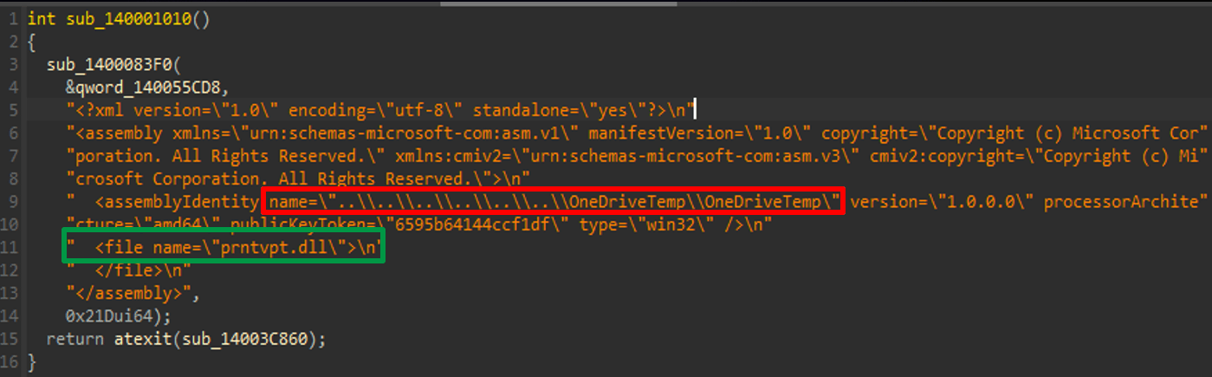

Recommendation:
- Validate File Paths – Always validate and sanitize file paths before performing file operations to prevent misuse of hard links.
- Restrict Hard Link Creation – Configure security settings in Microsoft Windows to restrict unauthorized users from creating hard links to sensitive files.
- Proper Permission Checks – Ensure applications verify file permissions and ownership before reading or modifying any file.
- Secure File Handling – Avoid allowing applications to directly access or modify critical system files without strict validation.
- Follow Security Best Practices – Implement secure coding standards and follow guidelines recommended by OWASP to prevent exploitation of hard link vulnerabilities.

2) Vulnerability Name: Active Debug Code
CWE Number: CWE-489
OWASP Category: security misconfiguration
Description:
Active Debug Code Vulnerability occurs when debug or test code is left enabled in a production environment. In applications running on Microsoft Windows or web systems, developers sometimes include debugging features to test functionality. If this debug code is not removed before deployment, attackers may exploit it to access sensitive information, bypass security controls, or manipulate system behavior. This vulnerability is categorized under Security Misconfiguration by OWASP and is related to CWE-489.

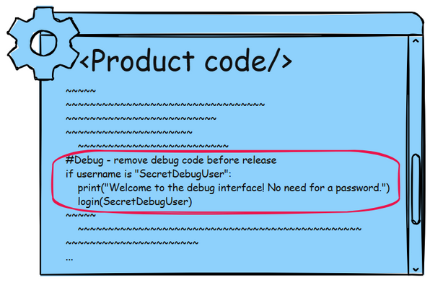

Business Impact
Active debug code can expose sensitive information such as system details, configuration data, or internal application logic. Attackers may use this information to exploit other vulnerabilities, gain unauthorized access, or compromise the system. This can lead to data breaches, service disruption, financial loss, and reputational damage for the organization.

Recommendation
- Disable Debug Mode – Ensure all debug features and testing code are disabled before deploying the application to production.
- Remove Debug Statements – Developers should remove unnecessary debug logs, messages, and test functions from the final application.
- Secure Configuration Management – Properly configure system and application settings to prevent debug features from being enabled in production.
- Regular Security Testing – Perform security reviews and vulnerability scans to identify and remove active debug code.
- Follow Security Best Practices – Follow secure development and deployment guidelines recommended by OWASP.

3) Vulnerability Name: Use of Obsolete
CWE Number: CWE-447
OWASP Category: Software Supply Chain Failures

Description:
Use of Obsolete Components Vulnerability occurs when an application uses outdated or unsupported libraries, frameworks, or software components. These obsolete components may contain known security vulnerabilities that attackers can exploit to compromise the system. If organizations fail to update or replace these components, it can expose the application to various security risks. This vulnerability is related to CWE-447 and is categorized under Software Supply Chain Failures by OWASP.

Business Impact:

Using obsolete components can expose applications to known security vulnerabilities and attacks. Attackers may exploit these weaknesses to gain unauthorized access, steal sensitive data, or disrupt services. This can result in data breaches, financial loss, service downtime, and reputational damage for the organization.

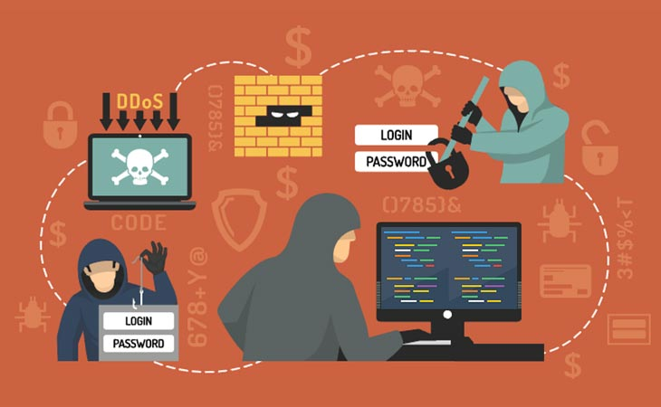

Recommendation:
- Update Components Regularly – Ensure all libraries, frameworks, and software components are updated to the latest secure versions.
- Remove Unsupported Software – Avoid using outdated or unsupported components in the application.
- Monitor Security Advisories – Regularly check for security updates and vulnerability reports related to the software components used.
- Use Trusted Sources – Download libraries and dependencies only from trusted and official sources.
- Follow Security Best Practices – Follow secure development guidelines recommended by OWASP to manage software supply chain risks.

4) Vulnerability Name: Insufficient Entropy
CWE Number: CWE-331
OWASP Category: Cryptographic Failures
Description:

Insufficient Entropy Vulnerability occurs when an application generates predictable or weak random values for security-sensitive operations such as session IDs, tokens, or cryptographic keys. If the randomness is not strong enough, attackers may be able to guess or predict these values and gain unauthorized access to the system. This vulnerability is related to CWE-331 and is categorized under Cryptographic Failures by OWASP.
Business Impact:
Weak randomness can allow attackers to predict session IDs, authentication tokens, or encryption keys. This may lead to account hijacking, unauthorized access, data breaches, and system compromise. As a result, organizations may face financial loss, service disruption, and reputational damage.

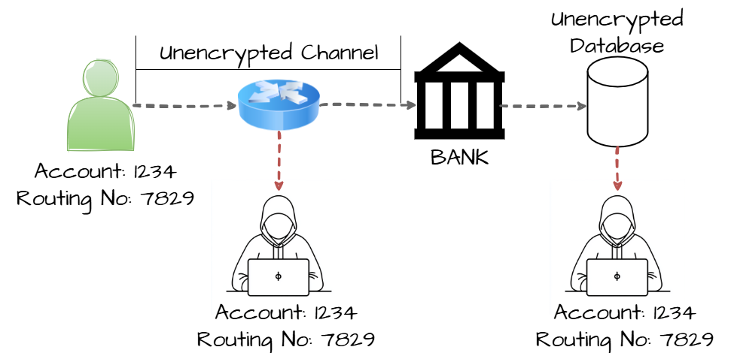

Recommendation
- Use Secure Random Generators – Use strong cryptographic random number generators provided by secure libraries.
- Avoid Predictable Values – Do not generate tokens, session IDs, or keys using predictable values such as timestamps or simple counters.
- Implement Strong Cryptographic Practices – Use well-tested cryptographic algorithms and security libraries.
- Regular Security Testing – Perform security testing to detect weak randomness in applications.
- Follow Security Guidelines – Follow secure coding practices recommended by OWASP to prevent cryptographic vulnerabilities.

5) Vulnerability Name: Process Control
CWE Number: CWE-114
OWASP Category: Injection
Description:
Process Control (CWE-114) vulnerability occurs when an application loads or executes external processes, executables, or libraries without proper validation and control mechanisms. If the application relies on relative paths or insecure search paths, attackers may place malicious files in those locations. When the application attempts to load the process or library, the malicious file may be executed instead of the intended one. This can result in unauthorized command execution and compromise the security of the system.
Business Impact:
Exploitation of this vulnerability may allow attackers to execute arbitrary or malicious code on the affected system. This could lead to unauthorized access to sensitive information, modification or deletion of critical data, and installation of malware. In severe cases, attackers may gain higher privileges and take full control of the application or server. Such incidents can cause financial loss, reputational damage, and disruption of business operations.

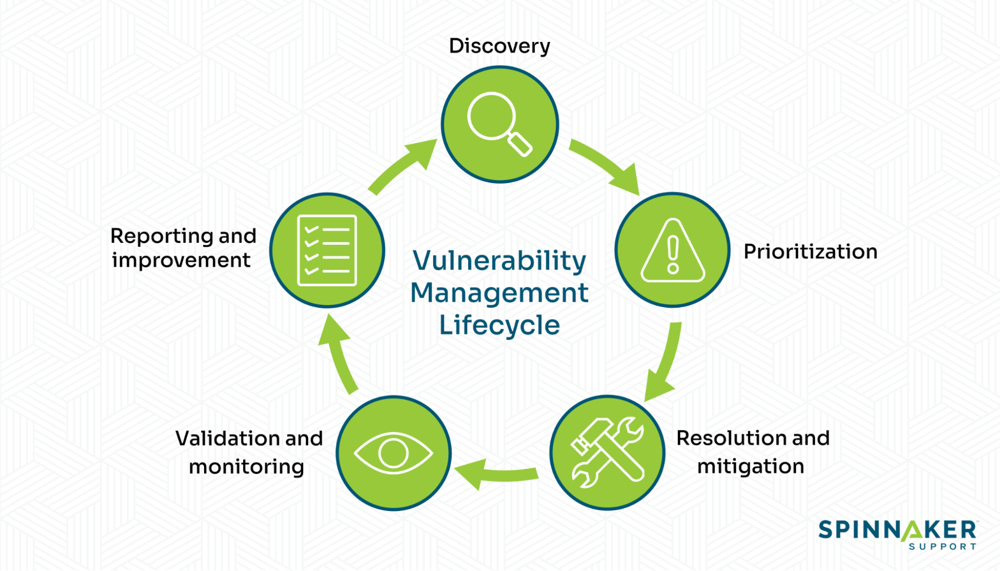

Recommendation:
- Always use absolute and trusted paths when loading executables, processes, or dynamic libraries.
- Avoid using relative paths or environment variables that attackers could manipulate.
- Implement strict input validation and sanitization for any user input that influences process execution.
- Apply least privilege principles and restrict file system permissions so unauthorized users cannot place files in executable search paths.
- Enable code signing and integrity verification to ensure only trusted binaries are executed.
- Regularly perform security testing, vulnerability assessments, and secure code reviews to identify and remediate process control weaknesses. 🔐

6) Vulnerability Name: Improper privilege management
CWE Number: CWE-269
OWASP Category: Insecure Design
Description:
Improper Privilege Management (CWE-269) occurs when an application does not properly manage or enforce user privileges and access controls. This can allow users or attackers to perform actions beyond their authorized permissions. Due to weak privilege restrictions or incorrect access control implementation, unauthorized users may gain elevated privileges or access sensitive system functions.
Business Impact:
If exploited, this vulnerability may allow attackers to gain unauthorized access to sensitive data or critical system functionalities. It can lead to privilege escalation, data manipulation, or system compromise. Such issues may result in data breaches, financial loss, reputational damage, and disruption of normal business operations.

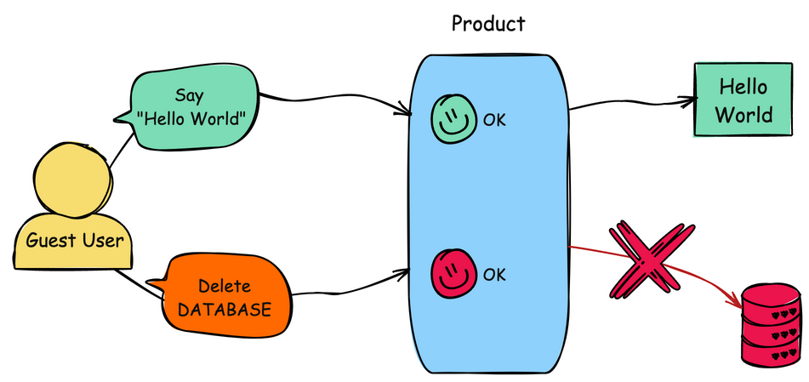

Recommendation:
- Implement proper role-based access control (RBAC) to ensure users only have necessary permissions.
- Apply the principle of least privilege so users receive only the minimum access required.
- Regularly review and update user privileges to remove unnecessary permissions.
- Implement strong authentication and authorization mechanisms for accessing sensitive functions.
- Conduct regular security audits and access control testing to identify and fix privilege management issues.

7) Vulnerability Name: Use of hard coded passwords
CWE Number: CWE-259
OWASP Category: Authentication Failure

Description:
Use of Hard-Coded Passwords (CWE-259) occurs when passwords or authentication credentials are directly embedded within the application source code. This practice makes the credentials easily discoverable by anyone who has access to the code, configuration files, or compiled binaries. Attackers can exploit this vulnerability to obtain sensitive credentials and gain unauthorized access to the system or related services.
Business Impact:
If hard-coded passwords are exposed, attackers may gain unauthorized access to applications, databases, or internal systems. This can lead to data breaches, leakage of sensitive information, and unauthorized system modifications. It may also compromise system security, damage the organization’s reputation, and result in financial or operational losses.

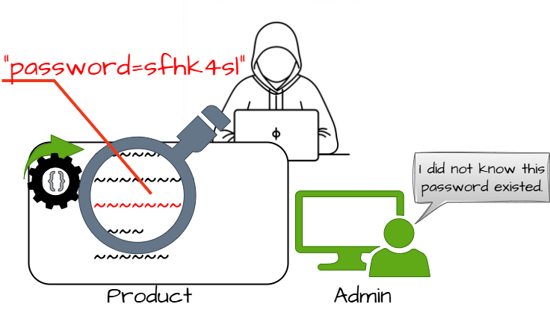

Recommendation:
- Avoid storing passwords or sensitive credentials directly in the source code.
- Use secure credential management solutions such as environment variables or secret management tools.
- Implement strong encryption or hashing mechanisms to protect stored credentials.
- Regularly rotate and update passwords to reduce the risk of credential compromise.
- Restrict access to sensitive configuration files and perform regular security reviews of the codebase.

8) Vulnerability Name: Untrusted search path
CWE Number: CWE-426
OWASP Category: Software or data integrity failures
Description:
Untrusted Search Path vulnerability occurs when an application loads executable files (like DLL, EXE, or scripts) from directories that are not properly controlled or validated. The operating system searches multiple folders to locate the required file, and if an attacker places a malicious file with the same name in a directory that is searched first, the application may execute that malicious file instead of the legitimate one. This can allow attackers to run unauthorized code with the privileges of the affected application.
Business Impact:
If this vulnerability is exploited, attackers may execute malicious code within the system. This could lead to unauthorized access, data theft, system compromise, or modification of critical files. In business environments, it may result in loss of sensitive information, disruption of services, financial loss, and damage to the organization’s reputation.



Recommendation:
- Configure applications to use absolute and trusted paths when loading executable files or libraries.
- Remove writable permissions from directories that are included in the system search path.
- Ensure that only authorized users have permission to modify system directories.
- Regularly review and secure environment variables such as the PATH variable.
- Apply the latest security patches and updates to the operating system and applications.

9) Vulnerability Name: Information loss of omission
CWE Number: CWE-221
OWASP Category: Security logging &amp; Alerting Failures
Description:
Insufficient logging is a security vulnerability where a system or application fails to record important events and activities. These activities may include user logins, failed login attempts, system errors, configuration changes, and access to sensitive data. Without proper logging, it becomes difficult to detect unauthorized access, security breaches, or suspicious activities. Logging is important for monitoring system behavior and identifying potential security incidents.

Business Impact:
If proper logging is not implemented, organizations may not be able to detect security incidents or cyber-attacks in a timely manner. This can lead to data breaches, loss of sensitive information, and damage to the organization’s reputation. Additionally, the absence of logs can make it difficult to investigate incidents and identify the root cause of a security issue. It may also result in non-compliance with security standards and regulatory requirements, which can lead to financial losses and legal consequences.
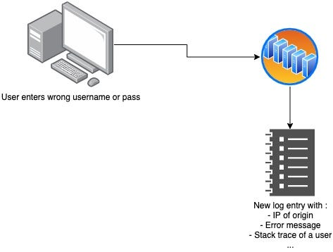

Recommendation:
- Implement comprehensive logging for critical system activities such as login attempts, user actions, and system changes.
- Ensure logs are stored securely and protected from unauthorized access or modification.
- Use centralized logging systems to collect and manage logs from different sources.
- Regularly monitor and review logs to detect suspicious or abnormal activities.
- Implement automated alert mechanisms to notify administrators of potential security incidents.
- Establish a log retention policy to maintain logs for a defined period for audit and investigation purposes.

10) Vulnerability Name: Unchecked error condition
CWE Number: CWE-391
OWASP Category: Mishadling of Exceptional conditions
Description:
Unchecked Error Condition is a vulnerability that occurs when a program or application does not properly check or handle error messages returned by functions, system calls, or external processes. When errors are ignored or not validated, the application may continue execution even though a failure has occurred. This can lead to unexpected behavior, system crashes, or security weaknesses. Attackers may exploit these situations to cause denial of service, manipulate application behavior, or gain unauthorized access.
Business Impact:
If error conditions are not properly checked, the application may behave unpredictably and become unstable. This can lead to service interruptions, system failures, or loss of critical data. In some cases, attackers may exploit these weaknesses to bypass security controls or disrupt business operations. As a result, organizations may face financial losses, reduced system reliability, and damage to their reputation.

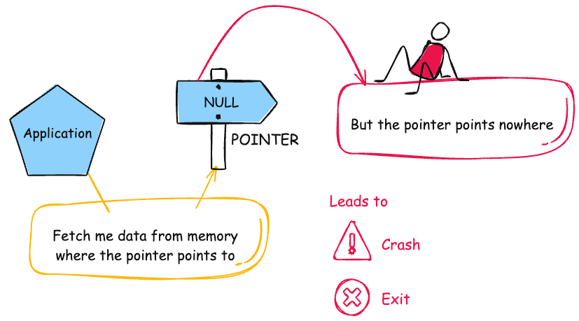

Recommendation:
- Ensure all functions, system calls, and API responses are properly checked for error conditions.
- Implement proper error handling mechanisms to manage failures safely.
- Log all errors and exceptions to support monitoring and troubleshooting.
- Use secure coding practices to validate return values and handle unexpected conditions.
- Perform regular code reviews and security testing to identify and fix unchecked error conditions.
- Provide meaningful error messages internally while avoiding exposure of sensitive system information to users.

Stage 2

Overview :-
Nessus is a vulnerability scanner developed by Tenable, Inc. It is a remote scanner, meaning that it does not need to be installed on the target host to scan it. Nessus works by sending a variety of probes to the target host in order to identify vulnerabilities. These probes can include network traffic, operating system commands, and application requests.
Nessus uses a plugin-based architecture. Plugins are small pieces of code that are designed to identify specific vulnerabilities. There are over 1200 plugins available for Nessus, covering a wide range of vulnerabilities in operating systems, applications, and network devices.
When Nessus scans a host, it first uses a discovery plugin to identify the operating system and services running on the host. Once the host has been discovered, Nessus runs a series of plugins to test for vulnerabilities. For each vulnerability that Nessus finds, it provides a detailed report that includes the severity of the vulnerability, the steps to reproduce the vulnerability, and the steps to remediate the vulnerability.

Nessus can be used to scan a variety of targets, including single hosts, networks, and web applications. It can also be used to scan specific ports and services. Nessus can be configured to run scans on a schedule or manually.
Here is a step-by-step explanation of how Nessus works:
1. Nessus connects to the target host using a variety of protocols, including TCP, UDP, and ICMP.
2. Nessus sends a series of probes to the target host in order to identify its operating system and services.
3. Nessus runs a series of plugins to test for vulnerabilities.
4. Nessus generates a report that includes the severity of each vulnerability, the steps to reproduce the vulnerability, and the steps to remediate the vulnerability.
Nessus is a valuable tool for security professionals who need to identify and remediate vulnerabilities in their networks. It is easy to use and provides comprehensive reports that can be used to prioritise remediation efforts.
Here are some of the benefits of using Nessus:
● Comprehensive vulnerability coverage: Nessus has over 1200 plugins available, covering a wide range of vulnerabilities in operating systems, applications, and network devices.
● Easy to use: Nessus has a user-friendly interface that makes it easy to configure and run scans.
● Comprehensive reporting: Nessus provides detailed reports that include the severity of each vulnerability,the steps to reproduce the vulnerability, and the steps to remediate the vulnerability.
● Scalability: Nessus can be used to scan a variety of targets, including single hosts, networks, and web applications.
● Flexibility: Nessus can be configured to run scans on a schedule or manually.
Nessus is a powerful tool that can be used to improve the security of any network. It is a valuable asset for any security professional.

How Nessus Works
Nessus is a vulnerability scanning tool used to identify security weaknesses in systems, networks, and applications. It helps organizations detect potential threats before attackers exploit them.
The working process of Nessus mainly includes the following steps:
1. Target Identification
First, the user provides the IP address, domain name, or network range of the system that needs to be scanned. Nessus identifies the target devices connected to the network.
2. Scanning Process
Nessus scans the target system using thousands of predefined vulnerability plugins. These plugins check for known vulnerabilities, misconfigurations, outdated software, and security weaknesses.
3. Vulnerability Detection
During the scan, Nessus compares the system information with its vulnerability database to identify possible security issues.
4. Risk Assessment
Each detected vulnerability is assigned a severity level such as Low, Medium, High, or Critical, based on the potential risk it may cause to the system.
5. Report Generation
After the scan is completed, Nessus generates a detailed report. This report includes:
- Vulnerability name
- Description
- Severity level
- Business impact
- Recommendations to fix the issue

6. Remediation
Security administrators review the report and apply the recommended fixes to improve the overall security of the system.
Target website :-https://ginandjuice.shop/
Target ip address:-34.246.169.176

List of vulnerability:-

s.no | Vulnerability name | Severity | plugins
1 | Nessus SYN scanner | Info | 11219
2 | SSL Cipher Block Chaining Cipher Suites Supported | Info | 70544
3 | TLS Next Protocols Supported | Info | 62564
4 | Web Server Crafted Request Vendor/Version Information Disclosure | Info | 11239
5 | TLS NPN Supported Protocol Enumeration | Info | 87242
6 | HyperText Transfer Protocol (HTTP) Information | Info | 24260
7 | Additional DNS Hostnames | Info | 46180
8 | Host Fully Qualified Domain Name (FQDN) Resolution | Info | 12053
9 | Web Server Crafted Request Vendor/Version Information Disclosure | Info | 11239
10 | Traceroute Information | Info | 10287

Report:
- Vulnerability Name: Nessus SYN scanner
Severity: info
Plugin: 11219
Port:80
Description:
A SYN scan is a network scanning technique used by security tools such as Nessus to discover open ports on a target system. In this method, the scanner sends a TCP SYN packet to the target port. If the port responds with a SYN-ACK packet, it indicates that the port is open; if it responds with an RST packet, the port is closed. Because the connection is not fully established, this technique is often called a half-open scan. Attackers or security testers can use this method to identify active services running on a system and detect potential vulnerabilities in the network.
Solution: Configure firewall rules and intrusion detection systems to block or detect unauthorized SYN scan attempts and restrict access to only trusted systems.
Business Impact: Unauthorized SYN scanning can reveal open ports and running services on a system, which helps attackers identify security weaknesses in the network. This information can be used to launch targeted attacks, exploit vulnerabilities, or gain unauthorized access to sensitive systems. As a result, confidential data may be exposed, systems may be compromised, and normal business operations can be disrupted. In severe cases, it may also lead to financial loss, legal issues, and damage to the organization’s reputation. 🔒⚠️

- Vulnerability Name: SSL Cipher Block Chaining Cipher Suites Supported
Severity: info
Plugin: 70544
Port: 443
Description: The server supports SSL/TLS Cipher Block Chaining (CBC) cipher suites, which are considered weak and may be vulnerable to certain cryptographic attacks. Attackers may exploit these weaknesses to intercept or manipulate encrypted communication between the client and the server.

Solution:
Disable weak CBC cipher suites on the server and enable only strong and secure TLS cipher suites. Update the SSL/TLS configuration to use modern protocols and strong encryption methods.
Business Impact:
If weak CBC cipher suites are supported, attackers may exploit these vulnerabilities to decrypt or manipulate sensitive information transmitted over the network. This can lead to exposure of confidential data such as login credentials, personal information, or business data. As a result, it may cause data breaches, loss of customer trust, financial loss, and damage to the organization’s reputation.

3) Vulnerability Name: TLS Next Protocols Supported
Severity: info
Plugin: 62564
Port: 443
Description:
The server supports TLS Next Protocol Negotiation (NPN), which is an older protocol used to negotiate the application layer protocol during a TLS connection. This protocol is deprecated and has been replaced by a more secure method. Supporting outdated protocols may introduce potential security risks.
Solution:
Disable TLS Next Protocol Negotiation (NPN) on the server and enable modern protocols such as Application Layer Protocol Negotiation (ALPN). Also ensure that the TLS configuration uses updated and secure protocol versions.
Business Impact:
If outdated TLS negotiation protocols are enabled, attackers may exploit weaknesses in the protocol to interfere with secure communications. This may result in reduced encryption security, potential data exposure, and increased risk of man-in-the-middle attacks. Such issues can lead to loss of sensitive information, disruption of secure services, and damage to business reputation and customer trust.

4) Vulnerability Name: Web Server Crafted Request Vendor/Version Information Disclosure
Severity: info
Plugin: 11239
Port: 80 / 443
Description:
The web server reveals vendor and version information when it receives specially crafted requests. This information may include the web server type and version details, which can help attackers identify the technologies used by the server.
Solution:
Configure the web server to hide or remove server banner information and disable unnecessary header details that reveal vendor or version information.
Business Impact:
If vendor and version information is disclosed, attackers can easily identify the server software and its version. This information can be used to search for known vulnerabilities related to that version and launch targeted attacks. As a result, the system may face security breaches, unauthorized access, or service disruption, which can affect business operations and damage the organization’s reputation.

5) Vulnerability Name: TLS NPN Supported Protocol Enumeration
Severity: info
Plugin: 87242
Port: 443
Description:
The server supports TLS Next Protocol Negotiation (NPN) and allows enumeration of supported protocols. This may reveal information about the protocols used by the server during TLS communication.
Solution:
Disable TLS Next Protocol Negotiation (NPN) and enable secure protocol negotiation methods such as ALPN. Also ensure the server uses updated and secure TLS configurations.

Business Impact:
If protocol enumeration is possible, attackers may gather information about supported protocols and use it to identify potential weaknesses in the server configuration. This information can help attackers plan targeted attacks, which may lead to exploitation of vulnerabilities, unauthorized access, or disruption of secure communication. Such incidents can result in data exposure, service downtime, financial loss, and damage to the organization’s reputation.

6) Vulnerability Name: HyperText Transfer Protocol (HTTP) Information
Severity: info
Plugin:24260
Port: 80
Description:
The web server discloses HTTP header information such as server details, technologies used, or configuration data in the response. This information can reveal details about the web server and application environment.
Solution:
Configure the web server to hide or remove unnecessary HTTP header information and disable server banner details that reveal system information.
Business Impact:
If HTTP information is disclosed, attackers can gather details about the web server, technologies, and configurations used in the system. This information can help them identify known vulnerabilities and plan targeted attacks. As a result, it may lead to unauthorized access, exploitation of system weaknesses, exposure of sensitive data, service disruption, and potential financial or reputational damage to the organization.

7) Vulnerability Name: Additional DNS Hostnames
Severity: info
Plugin: 46180

Port: 53 (DNS)
Description:
The scan has identified additional DNS hostnames associated with the target system. These hostnames may reveal other domains, subdomains, or services linked to the same server.
Solution:
Review and remove unnecessary DNS records and ensure that only required hostnames are publicly accessible. Proper DNS configuration and monitoring should be implemented.
Business Impact:
If additional DNS hostnames are exposed, attackers can discover hidden or less secure subdomains and services connected to the organization’s infrastructure. This information can help them perform further reconnaissance and identify potential weak points in the network. As a result, attackers may target vulnerable systems, leading to unauthorized access, service disruption, data exposure, and possible financial or reputational damage to the organization.

8) Vulnerability Name: Host Fully Qualified Domain Name (FQDN) Resolution
Severity: info
Plugin: 12053
Port: 53 (DNS)
Description:
The target host’s Fully Qualified Domain Name (FQDN) can be successfully resolved through DNS queries. This means the complete domain name associated with the host is publicly accessible and can be identified by external users. Attackers can use this information to understand the domain structure and identify related systems or services within the network.
Solution:
Ensure proper DNS configuration and limit unnecessary exposure of internal hostnames. Regularly review DNS records and remove unused or unnecessary entries. Implement DNS monitoring to detect suspicious lookup activities.
Business Impact:
If the FQDN is easily resolvable, attackers can gather valuable information about the organization’s network and domain structure. This information can help them perform further reconnaissance, identify potential targets, and plan more advanced attacks. As a result, it may increase the risk of unauthorized access, system exploitation, and potential disruption to business services.

9) Vulnerability Name: Web Server Crafted Request Vendor/Version Information Disclosure
Severity: info
Plugin: 11239
Port: 80 / 443
Description:
The web server discloses vendor and version information when it receives specially crafted requests. This information may include the web server software and its version details, which can help attackers identify the technologies used by the server.
Solution:
Configure the web server to hide or remove server banner information and disable unnecessary HTTP headers that reveal vendor or version details.
Business Impact:
If vendor and version information is exposed, attackers can easily identify the web server software and its specific version. They may use this information to search for known vulnerabilities related to that version and launch targeted attacks against the system. This may lead to exploitation of security weaknesses, unauthorized access, service disruption, and possible exposure of sensitive information, which can negatively affect business operations and the organization’s reputation.

10) Vulnerability Name: Traceroute Information
Severity: info
Plugin: 10287
Port: ICMP / Multiple Ports
Description:
Traceroute responses are enabled on the target system, which allows the network path and intermediate devices between the source and destination to be identified. This information may reveal details about the network infrastructure.

Solution:
Restrict or filter traceroute and ICMP responses using firewall rules to limit unnecessary exposure of network path information.
Business Impact:
If traceroute information is available, attackers may analyze the network path and identify routers, gateways, or other network devices used in the infrastructure. This information can help them understand the network architecture and perform further reconnaissance or targeted attacks, potentially leading to network exploitation, service disruption, or security breaches.

Stage 3

Title: Zero Trust Network Access (ZTNA) with
Zscaler: Securing User-to-Application Connectivity.

Overview:
1. Introduction:
Zero Trust Network Access (ZTNA) is a modern security approach that ensures secure access to applications and resources by verifying every user and device before granting access. Unlike traditional network security models that trust users inside the network, ZTNA follows a “never trust, always verify” principle. This approach helps organizations protect their applications, data, and systems from unauthorized access and cyber threats.
Zscaler provides a cloud-based ZTNA solution that enables secure user-to-application connectivity without exposing the internal network to the internet. It allows users to securely access applications from any location while maintaining strong authentication, identity verification, and continuous monitoring. This helps organizations support remote work and cloud applications securely.
By implementing ZTNA with Zscaler, organizations can reduce the risk of cyberattacks, prevent unauthorized access, and improve overall network security. It also helps in minimizing the attack surface, protecting sensitive business data, and ensuring that only verified users and devices can access critical applications. This modern security model is becoming essential for organizations adopting digital transformation and cloud-based infrastructure.

2. Objective of the Project:
The main objective of this project is to implement Zero Trust Network Access (ZTNA) using Zscaler to provide secure and controlled access between users and applications. This project focuses on ensuring that only authenticated and authorized users can access organizational resources.

Another objective is to enhance network security by following the principles of Zero Trust Network Access, where every user and device is continuously verified before access is granted. This helps in reducing the risk of unauthorized access, data breaches, and cyber threats.
The project also aims to protect sensitive business applications and data by minimizing the attack surface and enabling secure remote access. By implementing ZTNA, organizations can improve overall security, support remote work environments, and ensure safe connectivity to internal applications.

3. Technology Used
This project uses Zero Trust Network Access (ZTNA) technology to provide secure access between users and applications by verifying identity, device status, and access permissions before allowing connectivity. It ensures that only authorized users can access organizational resources.
The project also utilizes the cloud-based security platform provided by Zscaler, which enables secure user-to-application connectivity without exposing the internal network to the internet. This technology helps organizations protect applications, control access, and improve overall network security.
4. Legacy VPN Architecture:
Traditional Virtual Private Network (VPN) architecture allows remote users to securely connect to an organization’s internal network through an encrypted tunnel over the internet. After successful authentication, the user is connected to the internal network and can access internal resources such as servers, applications, and databases. This model is based on a perimeter-based security approach, where users inside the network are trusted once they log in. VPN gateways are usually placed at the edge of the network to control incoming connections. While this architecture was effective for traditional office environments, it was designed mainly for a smaller number of remote users and on-premise applications. As organizations adopt cloud services and remote work, this model becomes less efficient and harder to manage.

5. Limitations of Legacy VPN:
Legacy VPN solutions have several limitations in modern network environments. Once users connect to the VPN, they often receive broad access to the internal network instead of access to only specific applications. If an attacker compromises a user account or device, they may be able to move laterally within the network and access sensitive systems. VPNs can also create performance issues because all traffic is routed through the corporate network, which increases latency and network congestion. In addition, managing VPN infrastructure, user access, and security policies can become complex for large organizations. These limitations make traditional VPN less suitable for modern security requirements, which is why many organizations are moving toward modern approaches like Zero Trust Network Access to provide more secure and controlled access to applications.

6. Problems with Traditional VPN Security:
Traditional VPN security models rely on a perimeter-based approach where users are trusted once they successfully log in to the network. After authentication, users may gain broad access to internal systems and resources, which increases security risks if a user account or device is compromised. Attackers who gain VPN access can potentially move laterally within the network and access sensitive data. Additionally, VPN solutions can create performance issues because all traffic must pass through the corporate network. Managing VPN infrastructure, security policies, and user access can also become complex for organizations with many remote users. These challenges make traditional VPN security less effective against modern cyber threats.

7. Zero Trust Architecture:
Zero Trust Architecture is a modern security model that follows the principle of “never trust, always verify.” In this approach, no user or device is automatically trusted, even if they are inside the network. Every access request must be verified based on user identity, device status, and security policies before access is granted. This model provides secure and controlled access to applications rather than giving full network access. By continuously verifying users and devices, Zero Trust Architecture helps organizations reduce security risks, protect sensitive data, and prevent unauthorized access in modern cloud and remote work environments.

8. Zero Trust Solution using Zscaler:
Zscaler provides a cloud-based security platform that implements Zero Trust Network Access (ZTNA) to securely connect users to applications without exposing the internal network. Instead of connecting users to the entire network like traditional VPNs, Zscaler verifies user identity, device status, and security policies before granting access to specific applications. This approach improves security by ensuring that only authorized users can access organizational resources.
9. How Zscaler Eliminates Attack Surface:
Zscaler reduces the attack surface by hiding internal applications from the public internet. Applications are not directly exposed, which prevents attackers from discovering them through scanning or probing techniques. Access is provided only after authentication and policy verification. This limits unauthorized access and prevents attackers from moving laterally within the network.
10. Zscaler Components:
The main components of the Zscaler Zero Trust solution include the Zscaler Cloud Platform, Zscaler App Connector, and Zscaler Client Connector. The Zscaler Cloud acts as the central security platform that enforces security policies. The App Connector is deployed inside the organization’s network to securely connect internal applications to the Zscaler cloud. The Client Connector is installed on user devices to provide secure connectivity between users and applications.
11. Deployment Methodology:
The deployment process begins with integrating user identity systems with the Zscaler platform for authentication. Next, App Connectors are deployed inside the organization’s network to connect internal applications to the cloud. Security policies are then configured to define which users can access specific applications. After deployment, users can securely access applications from any location without using traditional VPN solutions.
12. Applications of Zscaler Zero Trust:
Zscaler Zero Trust solutions are used in organizations to provide secure remote access to internal applications, protect sensitive business data, and support cloud-based services. It is commonly used in enterprises that have remote employees, cloud infrastructure, and distributed networks. This technology helps organizations maintain secure connectivity while supporting modern digital workplaces.

13. Benefits of Zscaler Zero Trust:
Zscaler Zero Trust provides several advantages such as improved network security, reduced attack surface, and secure access to applications without exposing internal networks. It helps organizations prevent unauthorized access, protect sensitive data, and support remote work environments. Additionally, the cloud-based architecture simplifies security management and improves performance compared to traditional VPN solutions.
14. Identified Vulnerabilities Using Nessus:
Security vulnerabilities in the system can be identified using the vulnerability scanning tool Nessus. Nessus scans network devices, servers, and applications to detect security weaknesses such as outdated protocols, weak configurations, open ports, and information disclosure issues. Identifying these vulnerabilities helps organizations take corrective actions to improve their security posture and protect their network infrastructure. 🔒
Conclusion

Stage 1
In Stage 1 of this project, the basic concepts of modern network security and the limitations of traditional security models were analyzed. Traditional network architectures mainly rely on perimeter-based security approaches such as firewalls and VPNs. These methods assume that once a user is inside the network, they can be trusted. However, this approach creates several security risks because attackers who gain access to the network can easily move laterally and exploit internal resources. Due to the increase in remote work, cloud services, and mobile devices, organizations require a stronger and more flexible security model to protect their data and applications.
To address these challenges, the concept of Zero Trust security was introduced. The Zero Trust model follows the principle of “Never Trust, Always Verify.” It ensures that every user, device, and application request is authenticated, authorized, and continuously validated before access is granted. In this stage, the importance of implementing identity-based access control, device verification, and continuous monitoring was discussed. The study also highlighted how Zero Trust improves visibility, reduces unauthorized access, and enhances the overall security posture of an organization.

This stage helped in building a strong theoretical foundation for the project. It provided a clear understanding of why traditional security approaches are no longer sufficient and why organizations must shift towards Zero Trust architecture. By analyzing modern cyber threats and security challenges, the project identified the need for a secure and scalable solution like Zero Trust Network Access (ZTNA). This understanding prepared the groundwork for exploring how cloud-based security platforms can effectively implement the Zero Trust model in real-world environments.

Stage 2
In Stage 2, the project focused on studying the architecture and functionality of Zero Trust Network Access (ZTNA) using the cloud security platform provided by Zscaler. The analysis explored how ZTNA solutions differ from traditional VPN-based connectivity. Instead of providing users with access to the entire corporate network, ZTNA allows users to connect only to specific applications they are authorized to access. This approach significantly reduces the attack surface and prevents unauthorized users from accessing sensitive resources within the network.
This stage examined the main components involved in implementing ZTNA with the Zscaler platform. Important components such as Zscaler Private Access (ZPA), client connectors, cloud enforcement nodes, and identity providers were studied to understand how they work together to provide secure connectivity. These components ensure that users are authenticated through strong identity verification methods, including Single Sign-On (SSO) and multi-factor authentication (MFA). Additionally, the platform continuously evaluates device posture and security policies before granting access to enterprise applications.
Another key aspect analyzed in this stage was the role of cloud-based security inspection. By routing user traffic through secure cloud gateways, the platform can inspect and monitor network traffic for potential threats such as malware, unauthorized access attempts, and suspicious activities. This ensures that organizations maintain a high level of security without compromising user experience or performance.
Overall, Stage 2 demonstrated how ZTNA architecture effectively protects internal applications while enabling secure remote access. The study confirmed that cloud-based Zero Trust solutions provide greater flexibility, scalability, and protection compared to traditional network security models.

Stage 3
In Stage 3, the project evaluated the implementation benefits and overall effectiveness of the Zero Trust Network Access model using Zscaler. The analysis showed that adopting ZTNA significantly improves enterprise security by eliminating the need for traditional VPN infrastructure and by preventing direct exposure of internal applications to the internet. Instead of allowing users to connect to the network, the ZTNA model connects users directly to the applications they need, based on strict identity and access policies.
This stage also highlighted how the implementation of Zero Trust principles strengthens protection against modern cyber threats such as phishing attacks, insider threats, and unauthorized lateral movement within the network. By continuously verifying user identity, monitoring device health, and enforcing strict access policies, organizations can ensure that only trusted users and devices gain access to sensitive resources. This greatly reduces the chances of data breaches and system compromise.
Another important outcome observed in this stage is the improvement in operational efficiency and user experience. Since the security infrastructure is cloud-based, organizations can easily scale their security services without investing heavily in additional hardware or network infrastructure. Employees working remotely can securely access applications from any location without experiencing the performance limitations commonly associated with VPN connections.
In conclusion, the implementation of Zero Trust Network Access with Zscaler provides a modern and highly effective approach to securing user-to-application connectivity. The project demonstrates that Zero Trust architecture not only strengthens cybersecurity defenses but also supports the evolving needs of digital enterprises. By adopting this model, organizations can protect their critical resources, ensure secure access for users, and build a resilient security framework capable of addressing future cyber threats.
Future Scope:

Stage 1
In Stage 1, the project focused on understanding the basic concepts of Zero Trust architecture and the limitations of traditional network security models. In the future, this research can be expanded by exploring more advanced Zero Trust frameworks and security policies that further strengthen identity verification and access control mechanisms. As cyber threats continue to evolve, organizations will require more intelligent security solutions that can automatically detect suspicious activities and respond to threats in real time.

Future improvements may also include integrating artificial intelligence and machine learning techniques into Zero Trust systems. These technologies can analyze user behavior, detect unusual access patterns, and automatically prevent potential security breaches before they occur. Additionally, the Zero Trust model can be extended to protect not only users and applications but also Internet of Things (IoT) devices and cloud infrastructures. By implementing these advanced security mechanisms, organizations will be able to build a more proactive and adaptive cybersecurity environment.

Stage 2
In Stage 2, the architecture and functionality of Zero Trust Network Access (ZTNA) using the platform provided by Zscaler were studied. In the future, this architecture can be enhanced by integrating additional security technologies such as behavioral analytics, advanced threat detection systems, and automated policy enforcement. These improvements can help organizations strengthen their access control mechanisms and provide deeper visibility into user activities across the network.
Another future scope of this stage is the expansion of ZTNA solutions to support hybrid and multi-cloud environments. As many organizations continue to migrate their applications to cloud platforms, it becomes essential to ensure consistent security policies across all environments. By integrating Zero Trust with cloud security frameworks, organizations can protect applications regardless of whether they are hosted on-premises or in the cloud. Furthermore, future research can focus on improving scalability and performance to support a larger number of users and devices in global enterprise environments.

Stage 3
In Stage 3, the implementation and benefits of the ZTNA model using Zscaler were evaluated. The future scope of this stage includes further improving the efficiency and adaptability of Zero Trust solutions to meet the growing demands of modern digital organizations. As remote work and mobile access continue to increase, organizations will require more flexible and secure methods of connecting users to enterprise applications.
Future developments may also involve integrating Zero Trust systems with advanced identity management platforms, biometric authentication methods, and continuous device monitoring technologies. These enhancements can further strengthen user verification and prevent unauthorized access attempts. Additionally, the use of automation and intelligent security orchestration tools can simplify the management of Zero Trust policies and reduce the workload on security administrators.

In the coming years, Zero Trust architecture is expected to become a standard security framework for organizations worldwide. By continuously improving technologies such as ZTNA, companies can build stronger cybersecurity defenses, protect sensitive data, and ensure secure digital transformation across their networks.

Topics explored:
• OWASP Top 10
• Scanning
• Vulnerability Assessment
• Legacy VPN Architecture
• Zero Trust Security Model
• Overview of Zscaler Platform
• Zscaler Private Access (ZPA)
• Benefits of Zero Trust Architecture

Tools explored:
• Nessus Vulnerability Scanner
• Zscalar
• OWASP Top 10
• ginandjuice.shop

